Nonprofit Resiliency Fund
Application Instructions

How to Prepare and Submit your Application
Deadline to apply: Thursday, March 19, 2020 at 12 p.m. NOON PST
Applications are available online at: https://www.tfaforms.com/4804765
Please visit the Nonprofit Resiliency Fund Guidelines to review eligibility, project requirements and scoring criteria: http://oewd.org/nonprofit-resiliency-fund
The answers to all questions submitted in writing to oewd.procurement@sfgov.org by Monday, March 2nd at noon will be available to download on Thursday, March 5th at 5:00 p.m. at http://oewd.org/nonprofit-resiliency-fund.
Application Submission
We strongly advise applicants to use the information in this document to prepare their application responses in a separate document. Applicants should paste their completed answers into the online application when they are ready to submit.

Applicants are able to save their progress and return to the online application, as needed. To do so, complete the following steps:
- Check the “Save my progress and resume later” box at the top of the page.
- Enter an email address and password (use the same email address and password each time you exit the application) and hit “Save”.
- You will receive an email with a link that allows you to return to the application.
- OR you can return to the application website and select the “Resume a previously saved form” link to return to the application.
Required Materials with Application Submission
☐ Verifiable proof that the organization is currently without a permanent executive director, or has hired an executive director on or after January 1, 2019: This may be in the form of a letter of separation, job offer, or other documentation that clearly demonstrates a qualifying leadership transition.
☐ Proof of IRS good standing: Visit IRS-Tax Exempt Organization Search: https://apps.irs.gov/app/eos/pub78Search.do. Select Database "Pub 78 Data". Search for the applicant organization EIN number or Organization Name. Select the correct organization. Save a PDF of the screen that shows your organization listed with the confirmation “On Publication 78 Data List: Yes”
☐ Financials: Applicant’s budget for the current year and the most recently completed prior fiscal year budget. The previous year’s budget should include a report of actual income and expenses.
Only word docs and pdfs will be accepted. Please note that the City’s server limits the total size of all attachments per response to 30MB.
Required Information for Fiscally Sponsored Applicants:
- Legal name of Fiscal Sponsor Organization
- Fiscal Sponsor Organization executive leader’s name, phone number, and email address
- Fiscal Sponsor’s mailing address and supervisorial district (Choose the district number that most closely reflects where the fiscal sponsor's core administrative operations are based. District numbers can be found at: sfplanninggis.org/pim.)
- If the organization is fiscally sponsored, an authorized representative of the Fiscal Sponsor Organization must review the application, complete the Certification and Release on the final page, and submit the application. Applicants may save their application and share with their Fiscal Sponsor Organization to review and complete the Certification and Release. It is strongly recommended to due this in advance of the deadline to avoid any last-minute technical difficulties.
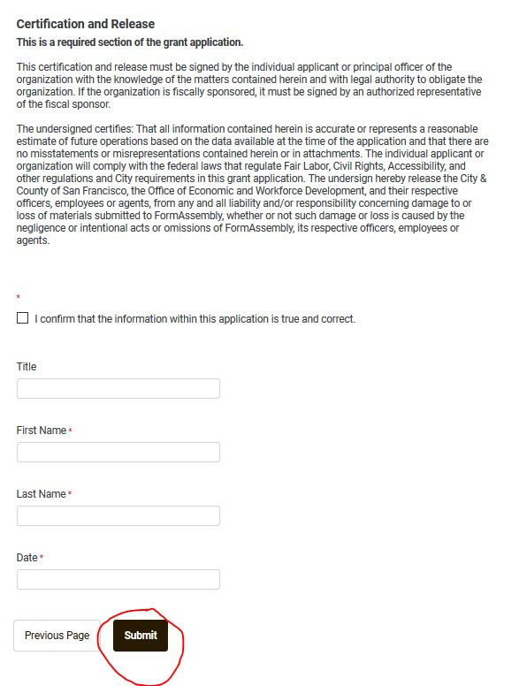

Application Questions and Project Requirements

Contact Person
- Applicant Lead – First and Last Name
- Title
- Phone
- Email Address

Organization Information:
- Legal Name of Applicant Organization
- EIN – Employer Identification Number (if your organization is fiscally sponsored, enter 0)
- Current Fiscal Year Estimated Revenue
- Current Fiscal Year Estimated Expense
- Address – Street, City, State and Zip Code
- Supervisorial District - (Choose the district number that most closely reflects where the fiscal sponsor's core administrative operations are based. District numbers can be found at: sfplanninggis.org/pim.)

Organization Leadership:
- Executive Director/CEO or the lead individual fulfilling these responsibilities – First and Last Name
- Title or Role
- Phone
- Email Address
- Current Fiscal Year Estimated Expense
- Address – Street, City, State and Zip Code
- Supervisorial District - (Choose the district number that most closely reflects where the fiscal sponsor's core administrative operations are based. District numbers can be found at: sfplanninggis.org/pim.)

Project Goals and Provider Qualifications
- Executive Summary: One line of text describing the proposed leadership transition project (Word limit: 25)
- Project Goals and Provider Qualifications: Describe the scope of the project, including how it is directly related to the leadership transition. The applicant should provide a description of staff and board roles in the project. If a coach, search firm, interim executive director or other service provider has been identified, applicant should establish the experience, qualifications and track record of the provider/s. (Word limit: 250)
- Provider Qualifications & Scope/s of Work: For each one-time cost for which you are seeking funding, attach a related scope of work from a qualified provider that includes:
-A description of the work to be done or services to be provided
-A project timeline or timeframe with benchmarks
-A budget/fee
-Information on the person(s) delivering the work including name, title, affiliation and relevant expertise
Applicant should upload all scopes of work and provider qualifications as one attachment.

Racial Equity
- Describe how your organization’s leadership advances racial equity. (Word limit: 250)

Application Questions
- Activities, Deliverables and timeline: This section should outline a plan of action that describes in sufficient detail the activities, deliverables and timeline of the project and how the proposed work will be accomplished. The plan should address all activities for which applicants seek funds. If other organizational effectiveness efforts are underway, describe how the proposed project will leverage past efforts, and how staff time and workload will be managed. Applicant should cite any unique or unusual features of the project. (Word limit: 250)
- Project Outcomes - Financial: How will this project contribute to maintaining and/or improving your organization’s financial well-being? What analysis has led you to this conclusion? (Word limit: 100)
- Project Outcomes - Mission: What is the expected impact of the partnership on the clients, audiences or other beneficiaries of the organization? What analysis has led you to this conclusion? (Word limit: 100)
- Performance Management and Reporting: Describe how project activities and outcomes will be collected and reported. Describe how you will determine whether the project has achieved its goals and how the organization will monitor the project as it is happening. (Word limit: 150)
- If applicable, please summarize your work on organizational effectiveness projects over the past 12 months. Include the general timeframe, milestones reached, and any work done to align missions and strategies. If this work was supported by a funder, please include the name of the funder and an estimate of the financial support received.) (Word limit: 200)

- Grant Request: Applicants may propose eligible expenses of at least $10,000 and up to $25,000 for leadership transition support. (Please enter a whole number with no decimals, do not use $ or other symbols.)

- Please provide a brief narrative detailing the financial management of the organization. (Word limit: 100)

Budget
- Has the Applicant received, identified or set aside any funds or other resources for the proposed leadership transition project? If so, please describe the source and amount of funds. (Word limit: 100)

Project Requirements:
☐ Project Budget: Please use the provided template to submit a budget for your leadership transition-related project: https://oewd.org/file/14906
All costs can be included in the budget but Resiliency Fund grants may not be used for fees paid to board members, capital costs, or ongoing programmatic and operational costs of the Applicant, including staff costs paid to employees or to independent consultants serving in the role of employees. This project does not require a match, however, it is understood that organizations invest staff time and other resources into capacity projects. Applicants are encouraged to reflect these costs in the overall budget as they are relevant to the selection criteria.
☐ Board of Directors: use the template provided at oewd.org/file/14910 to submit a list of the organization’s board members. If the organization is a fiscally sponsored project with no formal board, you may use the template to include a list of advisors.
Only word docs and pdfs will be accepted. Please note that the City’s server limits the total size of all attachments per response to 30MB.

Demographic Survey
To better serve our communities and maintain our commitment to equity, OEWD is collecting demographic data about grant applicants. This demographic survey is a work in progress. We understand that criteria/categories might not be perfect, and appreciate any feedback to revise categories that may better resonate with our communities.
The following demographic questions refer to the beneficiaries of your organization – the participants, clients, audience or other individuals who access services and resources.
Projected Annual Beneficiaries
Please estimate your organization's annual beneficiaries. Primary beneficiaries receive the bulk of services or resources. Secondary beneficiaries receive minor services or are impacted through the ripple effect of the organization's work. (For example, a Counseling Agency's primary clients could be youth receiving counseling services and its secondary clients could be family members that receive minor support services. For a Capacity Building Agency, primary clients could include nonprofit staff & board members registered for workshops and secondary clients could be clients served through the nonprofits that are supported.)
Primary Secondary
Are more than 50 percent of your beneficiaries people of color? And/or does your mission statement explicitly mention communities of color? (yes/no)
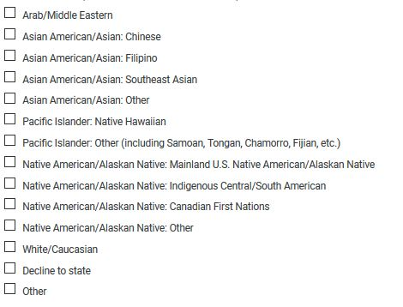
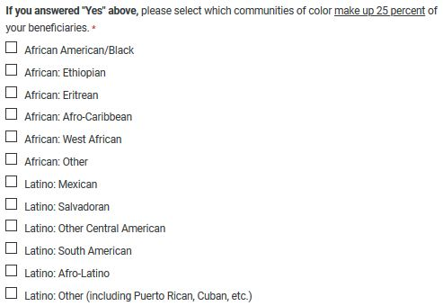

Are more than 50 percent of your beneficiaries women? And/or does your mission statement explicitly mention women?
Are more than 50 percent of your beneficiaries LGBQ or two-spirit? And/or does your mission statement explicitly mention LGBQ or two-spirit communities?
Are more than 50 percent of your beneficiaries people with disabilities? And/or does your mission statement explicitly mention the disability community?
Are more than 50 percent of your beneficiaries children and youth and/or family with children and youth? And/or does your mission statement explicitly mention families and/or children and/or youth?
If your organization has a community focus that was not mentioned above, please provide a brief summary of the community(ies) you serve.

Do you have any suggestions for OEWD about this survey or the application process? If so, use the space below.

Submission, Certification and Release
The application is not complete until it is authorized and submitted. Applicants who successfully submit the online form will receive an automatically-generated confirmation email.

The certification and release must be signed by the individual applicant or principal officer of the organization legal authority to obligate the organization. If the organization is fiscally sponsored, it must be signed by an authorized representative of the fiscal sponsor (see page 2 for a screenshot of the certification, release and submission button).

When you are ready to submit the application, please take care to hit the SUBMIT button at the bottom of page 8 of the application, NOT the save button.

Scoring Criteria
Panelists are instructed to use the scoring criteria published in the Nonprofit Resiliency Fund Guidelines when reviewing each application. To view the Guidelines, visit: http://oewd.org/nonprofit-resiliency-fund

